ASSINGMENT - 02

CREATING A TABLE

DISPLAYING TABLE

INSERTING VALUES

insert into students values(100,'anitha','ai&ds',95);

insert into students values(101,'surya','ai&ds',90);

insert into students values(102,'jeevitha','ai&ds',98);

DISPLAYING THE VALUES

ALTER TABLE

UPDATING THE VALUES

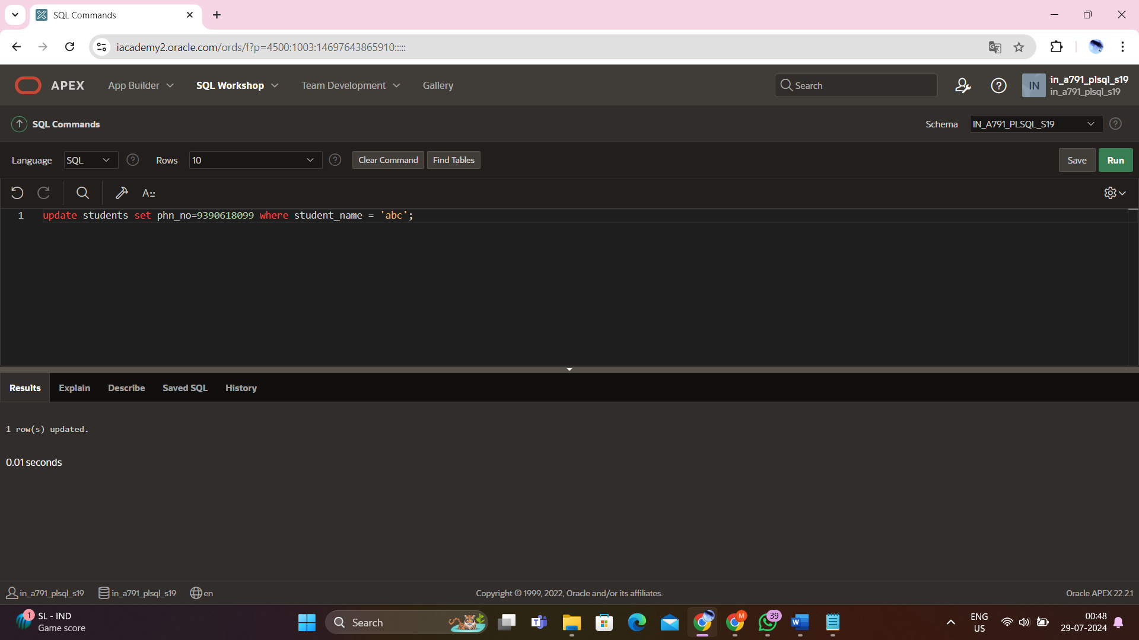

TRUNCATE TABLE

DROP TABLE

SUM

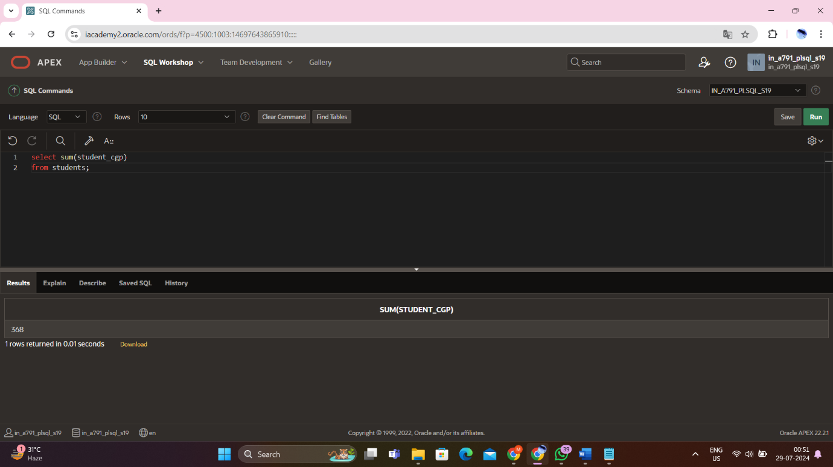

MAX

MIN

AVERAGE

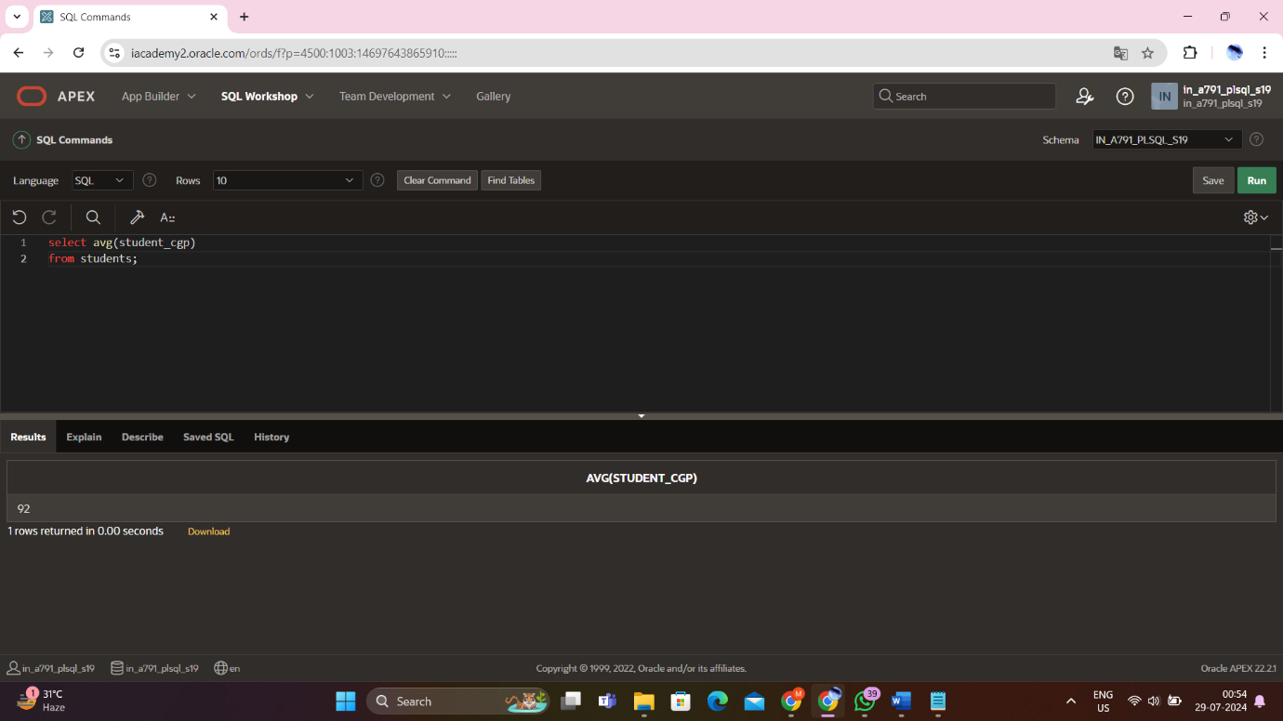

COUNT

ORDER BY

GROUP BY

